Phase 3: Flow Creation and Trigger Configuration
The first phase involves creating the automation flow and defining when it should run.

Activity 1: Create the Flow
- Go to All Menus.
- Search for Flow Designer.
- Open Flow Designer under Process Automation.
- Click New in the top-right corner.
- Select Flow.
- Enter the following details:
  - Name: Auto Classify School IT Tickets
  - Application: Global
- Click Build Flow.
The flow acts as the main automation component. It controls the classification process and performs the required actions automatically.
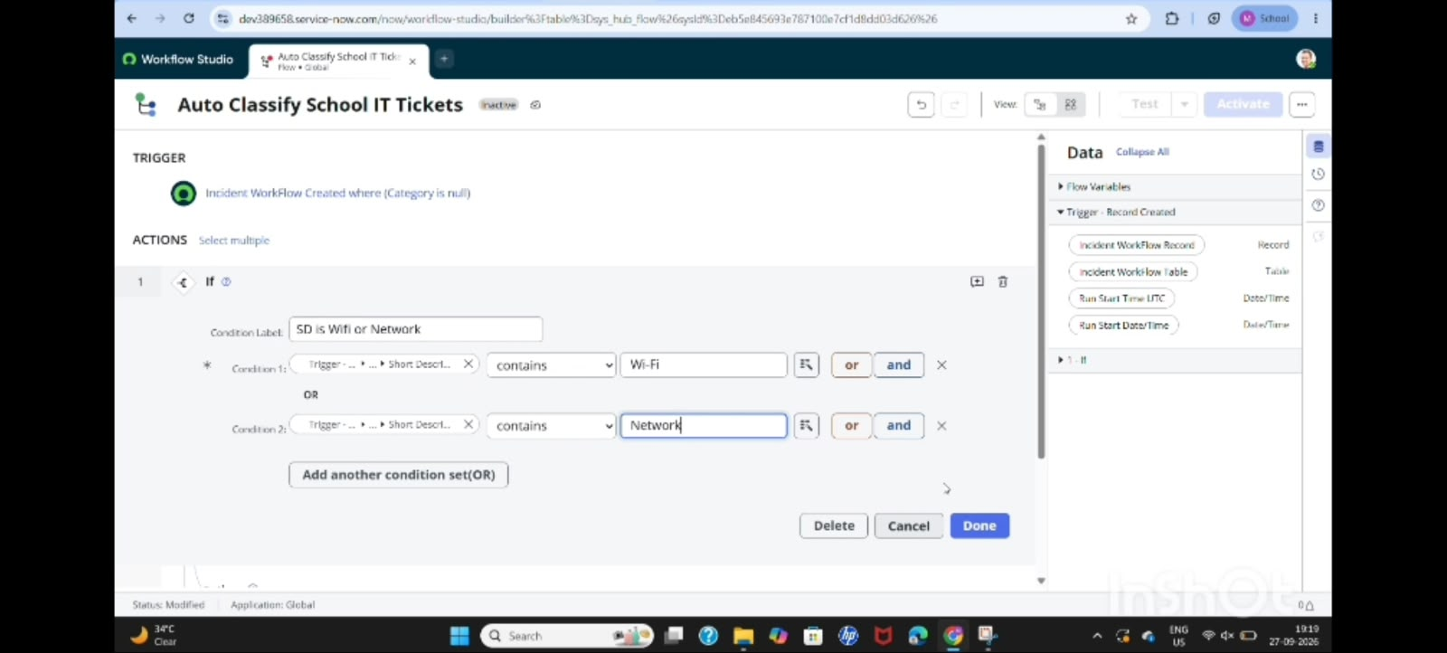

Activity 2: Configure the Trigger
Set the trigger as:
- Trigger: Record Created
- Table: Incident Workflow
- Condition: Category is Empty
This ensures that the flow runs whenever a new incident is created and the category has not yet been assigned manually.
The trigger prevents unnecessary manual classification and starts the automation immediately after ticket submission.
